**Supplementary Materials**

**Supplementary Tables**

**Table S1.** Summary of seven groups of quorum sensing signaling molecules and quorum sensing genes in each group.

|  |  |  |  |
| --- | --- | --- | --- |
| **Group** | **Gene** | | **Annotation** |
| AHLs | filI | | homolog of LuxI, originally identified in in *Methanosaeta harundinacea* 6Ac |
| AHLs | filR | | homolog of LuxR, originally identified in *Methanosaeta harundinacea* 6Ac |
| AHLs | hdtS | | 1-acyl-sn-glycerol-3-phosphate acyltransferase [EC:2.3.1.51] | (GenBank) putative acylhomoserine lactone synthase |
| AHLs | pvdQ, quiP; | | acyl-homoserine-lactone acylase [EC:3.5.1.97] |
| AHLs | sdiA | | LuxR family transcriptional regulator, quorum-sensing system regulator SdiA |
| AHLs | hapR, luxR, litR | | TetR/AcrR family transcriptional regulator, hemagglutinin/protease regulatory protein |
| AHLs | cqsA | | CAI-1 autoinducer synthase [EC:2.3.-.-] |
| AHLs | cqsS | | two-component system, CAI-1 autoinducer sensor kinase/phosphatase CqsS [EC:2.7.13.3 3.1.3.-] |
| AHLs | lasI,luxl | | acyl homoserine lactone synthase [EC:2.3.1.184] |
| AHLs | rhlI, phzI, solI, cepI, tofI | | acyl homoserine lactone synthase [EC:2.3.1.184] |
| AHLs | ainS, luxM | | acyl homoserine lactone synthase [EC:2.3.1.184] |
| AHLs | ahlD, aiiA, attM, blcC | | N-acyl homoserine lactone hydrolase [EC:3.1.1.81] |
| AHLs | luxN | | two-component system, autoinducer 1 sensor kinase/phosphatase LuxN [EC:2.7.13.3 3.1.3.-] |
| AHLs | luxR, vanR | | LuxR family transcriptional regulator, transcriptional activator of the bioluminescence operon |
| AHLs | bjaI, rpaI, braI, rhiI | | acyl-homoserine lactone synthase [EC:2.3.1.228 2.3.1.229 2.3.1.-] |
| AHLs | bjaR1, rpaR, rhiR | | LuxR family transcriptional regulator, quorum-sensing system regulator BjaR1 |
| AHLs | rhlR, phzR | | LuxR family transcriptional regulator, quorum-sensing system regulator RhlR |
| AHLs | lasR | | LuxR family transcriptional regulator, quorum-sensing system regulator LasR |
| AHLs | solR, cepR, tofR | | LuxR family transcriptional regulator, quorum-sensing system regulator SolR |
| AHLs | cciR | | LuxR family transcriptional regulator, quorum-sensing system regulator CciR |
| AHLs | sinR, raiR, avsR | | LuxR family transcriptional regulator, quorum-sensing system regulator SinR |
| AHLs | expR | | LuxR family transcriptional regulator, quorum-sensing system regulator ExpR |
| AHLs | mvfR, pqsR | | LysR family transcriptional regulator, quorum-sensing system regulator MvfR |
| AHLs | cinI | | acyl homoserine lactone synthase [EC:2.3.1.184] |
| AHLs | raiI;cciI | | acyl homoserine lactone synthase [EC:2.3.1.184] |
| AHLs | cciI | | acyl homoserine lactone synthase [EC:2.3.1.184] |
| AHLs | cinR | | LuxR family transcriptional regulator, quorum-sensing system regulator CinR |
| AHLs | bisR | | LuxR family transcriptional regulator, quorum-sensing system regulator BisR |
| AHLs | fusK | | two-component system, NarL family, sensor histidine kinase FusK [EC:2.7.13.3] |
| AHLs | cviR | | LuxR family transcriptional regulator, quorum-sensing system regulator CviR |
| AHLs | cepR2; vjbR; | | LuxR family transcriptional regulator, quorum-sensing system regulator CepR2 |
| AHLs | luxI | | acyl homoserine lactone synthase [EC:2.3.1.184] |
| AHLs | traI, avsI | | acyl homoserine lactone synthase [EC:2.3.1.184] |
| AHLs | expI, esaI | | acyl homoserine lactone synthase [EC:2.3.1.184] |
| AHLs | cviI | | acyl homoserine lactone synthase [EC:2.3.1.184] |
| AI-2 | luxS | | S-ribosylhomocysteine lyase [EC:4.4.1.21] |
| AI-2 | lsrB | | AI-2 transport system substrate-binding protein |
| AI-2 | lsrC | | AI-2 transport system permease protein |
| AI-2 | lsrD | | AI-2 transport system permease protein |
| AI-2 | lsrA, ego | | AI-2 transport system ATP-binding protein |
| AI-2 | luxQ | | two-component system, autoinducer 2 sensor kinase/phosphatase LuxQ [EC:2.7.13.3 3.1.3.-] |
| AI-2 | luxP | | autoinducer 2-binding periplasmic protein LuxP |
| AI-2 | lsrK | | autoinducer-2 kinase [EC:2.7.1.189] |
| AI-2 | lsrG | | (4S)-4-hydroxy-5-phosphonooxypentane-2,3-dione isomerase [EC:5.3.1.32] |
| AI-2 | lsrR | | lsr operon transcriptional repressor |
| AIP | lepB | | lepB; signal peptidase I [EC:3.4.21.89] |
| AIP | agrC, blpH, fsrC | | two-component system, LytTR family, sensor histidine kinase AgrC [EC:2.7.13.3] |
| AIP | agrA, blpR, fsrA | | two-component system, LytTR family, response regulator AgrA |
| AIP | agrD | | AgrD protein |
| AIP | agrB | | accessory gene regulator B |
| AIP | agrC2 | | two-component system, LytTR family, sensor histidine kinase AgrC2 [EC:2.7.13.3] |
| AIP | agrA2 | | two-component system, LytTR family, response regulator AgrA2 |
| c-di-GMP | PDE | cdgJ; c-di-GMP phosphodiesterase [EC:3.1.4.52] | |
| c-di-GMP | DGC | E2.7.7.65; diguanylate cyclase [EC:2.7.7.65] | |
| c-di-GMP | PDE | dos; c-di-GMP-specific phosphodiesterase [EC:3.1.4.52] | |
| c-di-GMP | PDE | yahA; c-di-GMP-specific phosphodiesterase [EC:3.1.4.52] | |
| c-di-GMP | PDE | pdeA; c-di-GMP-specific phosphodiesterase [EC:3.1.4.52] | |
| c-di-GMP | PDE | vieA; c-di-GMP phosphodiesterase [EC:3.1.4.52] | |
| c-di-GMP | DGC | dgcB; diguanylate cyclase [EC:2.7.7.65] | |
| c-di-GMP | PDE | tipF; cyclic-di-GMP phosphodiesterase, flagellum assembly factor TipF | |
| c-di-GMP | gmr,PDE | c-di-GMP phosphodiesterase Gmr [EC:3.1.4.52] | |
| c-di-GMP | DGC | dge1; diguanylate cyclase [EC:2.7.7.65] | |
| c-di-GMP | DGC | adrA; diguanylate cyclase [EC:2.7.7.65] | |
| c-di-GMP | DGC | acgB; diguanylate cyclase [EC:2.7.7.65] | |
| c-di-GMP | DGC | cdgK; diguanylate cyclase [EC:2.7.7.65] | |
| c-di-GMP | DGC | cdgA; diguanylate cyclase [EC:2.7.7.65] | |
| c-di-GMP | DGC | cdgH; diguanylate cyclase [EC:2.7.7.65] | |
| c-di-GMP | DGC | cdgL; diguanylate cyclase [EC:2.7.7.65] | |
| c-di-GMP | DGC | cdgM; diguanylate cyclase [EC:2.7.7.65] | |
| c-di-GMP | DGC | K20960; diguanylate cyclase [EC:2.7.7.65] | |
| c-di-GMP | DGC | vpvC; diguanylate cyclase [EC:2.7.7.65] | |
| c-di-GMP | PDE | cdgC; c-di-GMP phosphodiesterase [EC:3.1.4.52] | |
| c-di-GMP | PDE | acgA; c-di-GMP phosphodiesterase [EC:3.1.4.52] | |
| c-di-GMP | PDE | cdpA; c-di-GMP phosphodiesterase [EC:3.1.4.52] | |
| c-di-GMP | PDE | rocS; c-di-GMP phosphodiesterase [EC:3.1.4.52] | |
| c-di-GMP | PDE | mbaA; c-di-GMP phosphodiesterase [EC:3.1.4.52] | |
| c-di-GMP | DGC | sadC; diguanylate cyclase [EC:2.7.7.65] | |
| c-di-GMP | DGC | siaD; diguanylate cyclase [EC:2.7.7.65] | |
| c-di-GMP | DGC | tpbB; diguanylate cyclase [EC:2.7.7.65] | |
| c-di-GMP | DGC | roeA; diguanylate cyclase [EC:2.7.7.65] | |
| c-di-GMP | DGC | mucR; diguanylate cyclase [EC:2.7.7.65] | |
| c-di-GMP | PDE | bifA; c-di-GMP phosphodiesterase [EC:3.1.4.52] | |
| c-di-GMP | DGC | yegE; diguanylate cyclase [EC:2.7.7.65] | |
| c-di-GMP | DGC | yedQ; diguanylate cyclase [EC:2.7.7.65] | |
| c-di-GMP | PDE | yhjH; c-di-GMP phosphodiesterase [EC:3.1.4.52] | |
| c-di-GMP | DGC | ydaM; diguanylate cyclase [EC:2.7.7.65] | |
| c-di-GMP | PDE | adrB; c-di-GMP phosphodiesterase [EC:3.1.4.52] | |
| DSF | rpfC | | two-component system, sensor histidine kinase RpfC [EC:2.7.13.3] |
| DSF | rpfG | | two-component system, response regulator RpfG |
| DSF | rpfF | | DSF synthase |
| DSF | rpfB; | | resuscitation-promoting factor RpfB |
| Others | blpC | | peptide pheromone BlpC |
| Others | blpA, lagD | | ATP-binding cassette, subfamily C, bacteriocin exporter |
| Others | blpB | | membrane fusion protein, peptide pheromone/bacteriocin exporter |
| Others | cad | | sex pheromone cAD1 |
| Others | comQ | | competence protein ComQ |
| Others | comX | | competence protein ComX |
| Others | comA | | ATP-binding cassette, subfamily C, bacterial, competence factor transporting protein [EC:3.4.22.-] |
| Others | comB | | competence factor transport accessory protein ComB |
| Others | comD | | two-component system, LytTR family, sensor histidine kinase ComD [EC:2.7.13.3] |
| Others | comC | | competence-stimulating peptide |
| Others | cylLL | | CylL-L protein |
| Others | cylM | | CylM protein |
| Others | cylB | | ATP-binding cassette, subfamily B, bacterial CylB |
| Others | cylR1 | | regulatory protein CylR1 |
| Others | cylLS | | CylL-S protein |
| Others | iad1 | | sex pheromone inhibitor iAD1 |
| Others | prgQ | | peptide inhibitor iCF10 |
| Others | nisA, spaS, epiA | | lantibiotic bacteriocin |
| Others | nisB, spaB, epiB | | lantibiotic biosynthesis protein |
| Others | nisC, spaC, epiC | | lantibiotic biosynthesis protein |
| Others | nisT, spaT | | ATP-binding cassette, subfamily B, bacterial NisT |
| Others | nisP, epiP | | lantibiotic leader peptide-processing serine protease [EC:3.4.21.-] |
| Others | nisK, spaK | | two-component system, OmpR family, lantibiotic biosynthesis sensor histidine kinase NisK/SpaK [EC:2.7.13.3] |
| Others | nprB | | neutral peptidase B [EC:3.4.24.-] |
| Others | phrA | | phosphatase RapA inhibitor |
| Others | phrC | | phosphatase RapC regulator |
| Others | phrE | | phosphatase RapE regulator |
| Others | phrF | | phosphatase RapF regulator |
| Others | phrG | | phosphatase RapG regulator |
| Others | phrK | | phosphatase RapK regulator |
| Others | phrH | | phosphatase RapH regulator |
| Others | secDF | | SecD/SecF fusion protein |
| Others | oppA, mppA | | oligopeptide transport system substrate-binding protein |
| PQS | phnB | | phnB; PhnB protein; PQS synthesis |
| PQS | phnA | | phnA; protein PhnA; PQS synthesis |
| PQS | pqsH | | 2-heptyl-3-hydroxy-4(1H)-quinolone synthase [EC:1.14.13.182] |
| PQS | pqsA | | anthranilate-CoA ligase [EC:6.2.1.32] |
| PQS | pqsB | | 2-heptyl-4(1H)-quinolone synthase subunit PqsB [EC:2.3.1.230] |
| PQS | pqsC | | 2-heptyl-4(1H)-quinolone synthase subunit PqsC [EC:2.3.1.230] |
| PQS | pqsD | | anthraniloyl-CoA anthraniloyltransferase [EC:2.3.1.262] |
| PQS | pqsL | | pqsL; HQNO biosynthesis monooxygenase PqsL |
| PQS | pqsR | | mvfR, pqsR; LysR family transcriptional regulator, quorum-sensing system regulator MvfR |
| PQS | pqsE | | 2-aminobenzoylacetyl-CoA thioesterase [EC:3.1.2.32] |

**Table S2.** Classification of methanogens based on functional genes involved in methanogenesis.

|  |  |  |  |  |
| --- | --- | --- | --- | --- |
| **Functional classification** | **Module** | **Enzyme** | **Definition** | **KO** |
| **Acetoclastic** | M00357 | 2.7.2.1 | acetate kinase | K00925 |
| 2.3.1.8 | phosphate acetyltransferase | K00625 |
| 6.2.1.1 | acetyl-CoA synthetase | K01895 |
| ACDS | acetyl-CoA decarbonylase/synthase complex | K00193; K00197; K00194 |
| **Hydrogenotrophic** | M00567 | 1.2.7.12 | formylmethanofuran dehydrogenase | K00200; K00201; K00202; K00203; K11261 |
| 2.3.1.101 | formylmethanofuran--tetrahydromethanopterin N-formyltransferase | K00672 |
| 3.5.4.27 | methenyltetrahydromethanopterin cyclohydrolase | K01499 |
| 1.5.98.1 | methylenetetrahydromethanopterin dehydrogenase | K00319 |
| 1.12.98.1 | coenzyme F420 hydrogenase subunit alpha | K00440; K00441; K00443 |
| 1.5.98.2 | 5,10-methylenetetrahydromethanopterin reductase | K00320 |
| **Methylotrophic** | M00563 | MtbA | [methyl-Co(III) methylamine-specific corrinoid protein]:coenzyme M methyltransferase | K14082 |
| MttB | trimethylamine---corrinoid protein Co-methyltransferase | K14083 |
| MttC | trimethylamine corrinoid protein | K14084 |
| MtbB | dimethylamine---corrinoid protein Co-methyltransferase | K16178 |
| MtbC | dimethylamine corrinoid protein | K16179 |
| MtmB | methylamine---corrinoid protein Co-methyltransferase | K16176 |
| MtmC | monomethylamine corrinoid protein | K16177 |
| M00356 | MtaA | [methyl-Co(III) methanol-specific corrinoid protein]:coenzyme M methyltransferase | K14080 |
| MtaB | methanol---5-hydroxybenzimidazolylcobamide Co-methyltransferase | K04480 |
| MtaC | methanol corrinoid protein | K14081 |
| **Common** |  | 2.1.1.86 | tetrahydromethanopterin S-methyltransferase | K00577; K00578; K00579; K00580; K00581; K00582; K00583; K00584 |
|  | 2.8.4.1 | methyl-coenzyme M reductase | K00399; K00400; K00401; K00402; K03421; K03422 |
|  | 1.8.98.1 | heterodisulfide reductase | K08264; K08265 |

**Table S3.** Potential quorum sensing genes identified in methanogen genomes.

|  |  |  |  |
| --- | --- | --- | --- |
| **Species** | **QS group** | **QS gene** | **Identity (≥30%)** |
| *Methanobacterium congolense* | AHLs | FilI | 100 |
| *Methanobacterium congolense* | AHLs | FilR | 100 |
| *Methanobacterium congolense* | AHLs | ahlD, aiiA, attM, blcC | 59.498 |
| *Methanobacterium congolense* | AHLs | qq | 42.529 |
| *Methanobacterium congolense* | AIP | lepB | 100 |
| *Methanobacterium congolense* | c-di-GMP | DGC | 40.476 |
| *Methanobacterium congolense* | PQS | phnB | 46.809 |
| *Methanobacterium formicicum* | AHLs | FilI | 39.884 |
| *Methanobacterium formicicum* | AHLs | FilR | 80.851 |
| *Methanobacterium formicicum* | AHLs | ahlD, aiiA, attM, blcC | 100 |
| *Methanobacterium formicicum* | AHLs | hapR, luxR, litR | 41.667 |
| *Methanobacterium formicicum* | AIP | lepB | 53.552 |
| *Methanobacterium formicicum* | PQS | phnB | 45.652 |
| *Methanobacterium lacus* | AHLs | FilI | 47.093 |
| *Methanobacterium lacus* | AHLs | FilR | 79.433 |
| *Methanobacterium lacus* | AHLs | ahlD, aiiA, attM, blcC | 49.818 |
| *Methanobacterium lacus* | AHLs | luxN | 40.625 |
| *Methanobacterium lacus* | AIP | lepB | 41.176 |
| *Methanobacterium lacus* | AIP | agrA, blpR, fsrA | 40 |
| *Methanobacterium lacus* | c-di-GMP | DGC | 41.27 |
| *Methanobacterium paludis* | AHLs | FilI | 30.12 |
| *Methanobacterium paludis* | AHLs | FilR | 54.874 |
| *Methanobacterium paludis* | AHLs | ahlD, aiiA, attM, blcC | 57.706 |
| *Methanobacterium paludis* | AIP | lepB | 54.497 |
| *Methanobacterium paludis* | c-di-GMP | DGC | 40.741 |
| *Methanobacterium paludis* | PQS | phnB | 40.678 |
| *Methanobacterium* sp. MB1 | AHLs | FilI | 37.356 |
| *Methanobacterium* sp. MB1 | AHLs | FilR | 85.106 |
| *Methanobacterium* sp. MB1 | AHLs | ahlD, aiiA, attM, blcC | 82.545 |
| *Methanobacterium* sp. MB1 | AIP | lepB | 51.613 |
| *Methanobacterium* sp. MZ-A1 | AHLs | FilI | 50 |
| *Methanobacterium* sp. MZ-A1 | AHLs | FilR | 80.142 |
| *Methanobacterium* sp. MZ-A1 | AHLs | ahlD, aiiA, attM, blcC | 74.007 |
| *Methanobacterium* sp. MZ-A1 | AHLs | hapR, luxR, litR | 45.833 |
| *Methanobacterium* sp. MZ-A1 | AHLs | luxN | 41.026 |
| *Methanobacterium* sp. MZ-A1 | AIP | lepB | 51.648 |
| *Methanobacterium* sp. MZ-A1 | PQS | phnB | 47.826 |
| *Methanobacterium subterraneum* | AHLs | FilI | 50 |
| *Methanobacterium subterraneum* | AHLs | FilR | 80.142 |
| *Methanobacterium subterraneum* | AHLs | ahlD, aiiA, attM, blcC | 74.007 |
| *Methanobacterium subterraneum* | AHLs | hapR, luxR, litR | 45.833 |
| *Methanobacterium subterraneum* | AHLs | luxN | 41.026 |
| *Methanobacterium subterraneum* | AIP | lepB | 52.198 |
| *Methanobacterium subterraneum* | c-di-GMP | DGC | 40.523 |
| *Methanobacterium subterraneum* | PQS | phnB | 47.826 |
| *Methanobrevibacter millerae* | AHLs | FilR | 31.921 |
| *Methanobrevibacter millerae* | AHLs | ahlD, aiiA, attM, blcC | 51.19 |
| *Methanobrevibacter millerae* | AIP | lepB | 41.558 |
| *Methanobrevibacter olleyae* | AHLs | FilR | 37.5 |
| *Methanobrevibacter olleyae* | AHLs | ahlD, aiiA, attM, blcC | 51.807 |
| *Methanobrevibacter ruminantium* | AHLs | FilR | 37.5 |
| *Methanobrevibacter ruminantium* | AI-2 | luxP | 41.25 |
| *Methanobrevibacter smithii* | AHLs | FilR | 30.588 |
| *Methanobrevibacter* sp. AbM4 | AHLs | ahlD, aiiA, attM, blcC | 100 |
| *Methanobrevibacter* sp. AbM4 | AI-2 | luxP | 40 |
| *Methanobrevibacter* sp. AbM4 | AIP | lepB | 42.657 |
| *Methanobrevibacter* sp. YE315 | AHLs | FilR | 35.556 |
| *Methanobrevibacter* sp. YE315 | AHLs | ahlD, aiiA, attM, blcC | 54.618 |
| *Methanobrevibacter* sp. YE315 | AI-2 | luxP | 43.077 |
| *Methanobrevibacter* sp. YE315 | AIP | lepB | 40.909 |
| *Methanocaldococcus bathoardescens* | AHLs | FilR | 34.043 |
| *Methanocaldococcus bathoardescens* | c-di-GMP | PDE | 61.972 |
| *Methanocaldococcus fervens* | AHLs | FilR | 38.298 |
| *Methanocaldococcus fervens* | Others | nisT, spaT | 40.244 |
| *Methanocaldococcus fervens* | c-di-GMP | PDE | 63.235 |
| *Methanocaldococcus fervens* | Others | nisT, spaT | 40.244 |
| *Methanocaldococcus fervens* | Others | nisT, spaT | 40.244 |
| *Methanocaldococcus infernus* | c-di-GMP | PDE | 60.811 |
| *Methanocaldococcus jannaschii* | AHLs | FilR | 43.478 |
| *Methanocaldococcus jannaschii* | Others | nisT, spaT | 41.25 |
| *Methanocaldococcus jannaschii* | Others | nisT, spaT | 41.25 |
| *Methanocaldococcus jannaschii* | Others | nisT, spaT | 41.25 |
| *Methanocaldococcus* sp. FS406-22 | AHLs | FilR | 38.298 |
| *Methanocaldococcus vulcanius* | AHLs | FilI | 45 |
| *Methanocaldococcus vulcanius* | AHLs | FilR | 39.583 |
| *Methanocaldococcus vulcanius* | c-di-GMP | PDE | 60.563 |
| *Methanocella arvoryzae* | AHLs | FilI | 45 |
| *Methanocella arvoryzae* | AHLs | FilR | 34.94 |
| *Methanocella arvoryzae* | AIP | lepB | 46.939 |
| *Methanocella arvoryzae* | c-di-GMP | PDE | 54.545 |
| *Methanocella arvoryzae* | c-di-GMP | DGC | 46.094 |
| *Methanocella arvoryzae* | DSF | rpfG | 46.939 |
| *Methanocella arvoryzae* | PQS | phnA | 66.667 |
| *Methanocella conradii* | AHLs | FilI | 36.17 |
| *Methanocella conradii* | AHLs | FilR | 42.336 |
| *Methanocella conradii* | AI-2 | luxP | 40.86 |
| *Methanocella conradii* | Others | nisP, epiP | 43.333 |
| *Methanocella conradii* | c-di-GMP | PDE | 47.436 |
| *Methanocella conradii* | DSF | rpfG | 43.077 |
| *Methanocella conradii* | Others | nisP, epiP | 43.333 |
| *Methanocella conradii* | PQS | phnA | 64.583 |
| *Methanocella conradii* | Others | nisP, epiP | 43.333 |
| *Methanocella paludicola* | AHLs | FilI | 60 |
| *Methanocella paludicola* | AHLs | FilR | 40.625 |
| *Methanocella paludicola* | AHLs | hapR, luxR, litR | 46 |
| *Methanocella paludicola* | c-di-GMP | PDE | 52.381 |
| *Methanocella paludicola* | c-di-GMP | DGC | 44.444 |
| *Methanocella paludicola* | PQS | phnA | 100 |
| *Methanococcoides burtonii* | AHLs | FilI | 43.243 |
| *Methanococcoides burtonii* | AHLs | FilR | 38.525 |
| *Methanococcoides burtonii* | AI-2 | luxQ | 48.78 |
| *Methanococcoides burtonii* | AIP | lepB | 47.826 |
| *Methanococcoides burtonii* | DSF | rpfC | 46.296 |
| *Methanococcoides burtonii* | PQS | phnA | 47.727 |
| *Methanococcoides methylutens* | AHLs | FilI | 32 |
| *Methanococcoides methylutens* | AHLs | FilR | 34.848 |
| *Methanococcoides methylutens* | AI-2 | luxQ | 41.004 |
| *Methanococcoides methylutens* | DSF | rpfC | 42.739 |
| *Methanococcus aeolicus* | AHLs | FilR | 37.931 |
| *Methanococcus maripaludis* | AHLs | FilR | 35.616 |
| *Methanococcus maripaludis* | AHLs | ahlD, aiiA, attM, blcC | 41.429 |
| *Methanococcus maripaludis* | AHLs | cciR | 40.816 |
| *Methanococcus maripaludis* | c-di-GMP | PDE | 52.113 |
| *Methanococcus vannielii* | AHLs | FilI | 38.636 |
| *Methanococcus vannielii* | AHLs | FilR | 36.986 |
| *Methanococcus vannielii* | AI-2 | luxP | 42.391 |
| *Methanococcus vannielii* | c-di-GMP | PDE | 52.857 |
| *Methanococcus voltae* | AHLs | FilI | 42.5 |
| *Methanococcus voltae* | AHLs | FilR | 35.484 |
| *Methanococcus voltae* | AHLs | luxN | 40 |
| *Methanococcus voltae* | AI-2 | luxP | 40 |
| *Methanococcus voltae* | c-di-GMP | PDE | 54.167 |
| *Methanocorpusculum labreanum* | AHLs | FilI | 34.177 |
| *Methanocorpusculum labreanum* | AHLs | FilR | 33.929 |
| *Methanoculleus bourgensis* | AHLs | FilI | 50 |
| *Methanoculleus bourgensis* | AHLs | FilR | 40.323 |
| *Methanoculleus bourgensis* | c-di-GMP | PDE | 55.844 |
| *Methanoculleus bourgensis* | c-di-GMP | DGC | 42.017 |
| *Methanoculleus bourgensis* | PQS | phnA | 43.21 |
| *Methanoculleus marisnigri* | AHLs | FilI | 40.909 |
| *Methanoculleus marisnigri* | AHLs | FilR | 38.462 |
| *Methanoculleus marisnigri* | AI-2 | luxP | 41.86 |
| *Methanoculleus marisnigri* | c-di-GMP | PDE | 54.321 |
| *Methanoculleus* sp. MAB1 | AHLs | FilI | 50 |
| *Methanoculleus* sp. MAB1 | AHLs | FilR | 40.323 |
| *Methanoculleus* sp. MAB1 | AI-2 | lsrA, ego | 41.379 |
| *Methanoculleus* sp. MAB1 | AI-2 | luxP | 40.86 |
| *Methanoculleus* sp. MAB1 | c-di-GMP | PDE | 54.321 |
| *Methanoculleus* sp. MAB1 | c-di-GMP | DGC | 42.017 |
| *Methanohalobium evestigatum* | AHLs | FilI | 33.824 |
| *Methanohalobium evestigatum* | AHLs | FilR | 35.156 |
| *Methanohalobium evestigatum* | AIP | lepB | 40.541 |
| *Methanohalobium evestigatum* | c-di-GMP | PDE | 59.091 |
| *Methanohalobium evestigatum* | DSF | rpfC | 45.267 |
| *Methanohalophilus halophilus* | AHLs | FilI | 40.541 |
| *Methanohalophilus halophilus* | AHLs | FilR | 39.189 |
| *Methanohalophilus halophilus* | AI-2 | luxQ | 44.715 |
| *Methanohalophilus halophilus* | DSF | rpfC | 40 |
| *Methanohalophilus mahii* | AHLs | FilI | 37.778 |
| *Methanohalophilus mahii* | AHLs | FilR | 39.394 |
| *Methanohalophilus mahii* | AI-2 | luxQ | 42.636 |
| *Methanohalophilus mahii* | c-di-GMP | DGC | 40.945 |
| *Methanohalophilus mahii* | DSF | rpfC | 43.534 |
| *Methanolacinia petrolearia* | AHLs | FilI | 45 |
| *Methanolacinia petrolearia* | AHLs | FilR | 39.726 |
| *Methanolacinia petrolearia* | Others | nisP, epiP | 48.214 |
| *Methanolacinia petrolearia* | c-di-GMP | PDE | 53.947 |
| *Methanolacinia petrolearia* | c-di-GMP | DGC | 41.096 |
| *Methanolacinia petrolearia* | Others | nisP, epiP | 48.214 |
| *Methanolacinia petrolearia* | Others | nisP, epiP | 48.214 |
| *Methanolobus psychrophilus* | AHLs | FilI | 44.586 |
| *Methanolobus psychrophilus* | AHLs | FilR | 58.865 |
| *Methanolobus psychrophilus* | AI-2 | luxQ | 41.634 |
| *Methanolobus psychrophilus* | c-di-GMP | PDE | 64.103 |
| *Methanolobus psychrophilus* | c-di-GMP | DGC | 41.818 |
| *Methanolobus psychrophilus* | DSF | rpfC | 43.673 |
| *Methanolobus psychrophilus* | PQS | phnB | 100 |
| *Methanomethylovorans hollandica* | AHLs | FilI | 31.418 |
| *Methanomethylovorans hollandica* | AHLs | FilR | 39.062 |
| *Methanomethylovorans hollandica* | AI-2 | luxQ | 42.718 |
| *Methanomethylovorans hollandica* | Others | nisP, epiP | 49.123 |
| *Methanomethylovorans hollandica* | c-di-GMP | PDE | 50.459 |
| *Methanomethylovorans hollandica* | DSF | rpfC | 41.631 |
| *Methanomethylovorans hollandica* | Others | nisP, epiP | 49.123 |
| *Methanomethylovorans hollandica* | PQS | phnB | 100 |
| *Methanomethylovorans hollandica* | Others | nisP, epiP | 49.123 |
| *Methanopyrus kandleri* | AHLs | FilI | 41.176 |
| *Methanopyrus kandleri* | AHLs | FilR | 36.765 |
| *Methanoregula boonei* | AHLs | FilI | 54.132 |
| *Methanoregula boonei* | AHLs | FilR | 50 |
| *Methanoregula boonei* | AI-2 | luxP | 43.939 |
| *Methanoregula boonei* | c-di-GMP | PDE | 54.878 |
| *Methanoregula boonei* | c-di-GMP | DGC | 43.571 |
| *Methanoregula formicica* | AHLs | FilI | 45.946 |
| *Methanoregula formicica* | AHLs | FilR | 50.725 |
| *Methanoregula formicica* | AI-2 | luxQ | 40.726 |
| *Methanoregula formicica* | c-di-GMP | PDE | 62.903 |
| *Methanosaeta harundinacea* | AHLs | FilI | 100 |
| *Methanosaeta harundinacea* | AHLs | FilR | 100 |
| *Methanosaeta harundinacea* | PQS | phnA | 50 |
| *Methanosalsum zhilinae* | AHLs | FilI | 37.313 |
| *Methanosalsum zhilinae* | AHLs | FilR | 32.031 |
| *Methanosalsum zhilinae* | c-di-GMP | PDE | 45.968 |
| *Methanosarcina acetivorans* | AHLs | FilI | 37.349 |
| *Methanosarcina acetivorans* | AHLs | FilR | 49.254 |
| *Methanosarcina acetivorans* | AHLs | luxN | 41.304 |
| *Methanosarcina acetivorans* | AIP | lepB | 41.176 |
| *Methanosarcina acetivorans* | Others | nisP, epiP | 40.845 |
| *Methanosarcina acetivorans* | c-di-GMP | PDE | 59.74 |
| *Methanosarcina acetivorans* | DSF | rpfC | 43.21 |
| *Methanosarcina acetivorans* | Others | nisP, epiP | 40.845 |
| *Methanosarcina acetivorans* | Others | nisP, epiP | 40.845 |
| *Methanosarcina barkeri* | AHLs | FilI | 44.231 |
| *Methanosarcina barkeri* | AHLs | FilR | 42.143 |
| *Methanosarcina barkeri* | AI-2 | luxQ | 44.231 |
| *Methanosarcina barkeri* | c-di-GMP | PDE | 50.98 |
| *Methanosarcina barkeri* | c-di-GMP | DGC | 44.231 |
| *Methanosarcina barkeri* | DSF | rpfC | 54.545 |
| *Methanosarcina barkeri* | DSF | rpfB; | 46.667 |
| *Methanosarcina barkeri* | DSF | rpfG | 42.857 |
| *Methanosarcina horonobensis* | AHLs | FilI | 46.154 |
| *Methanosarcina horonobensis* | AHLs | FilR | 45.324 |
| *Methanosarcina horonobensis* | AHLs | hapR, luxR, litR | 44.186 |
| *Methanosarcina horonobensis* | AHLs | luxN | 41.304 |
| *Methanosarcina horonobensis* | AI-2 | luxQ | 45.378 |
| *Methanosarcina horonobensis* | AIP | lepB | 43.333 |
| *Methanosarcina horonobensis* | Others | nisP, epiP | 41.379 |
| *Methanosarcina horonobensis* | c-di-GMP | PDE | 60 |
| *Methanosarcina horonobensis* | DSF | rpfC | 44.444 |
| *Methanosarcina horonobensis* | Others | nisP, epiP | 41.379 |
| *Methanosarcina horonobensis* | Others | nisP, epiP | 41.379 |
| *Methanosarcina horonobensis* | Others | nisP, epiP | 41.379 |
| *Methanosarcina lacustris* | AHLs | FilI | 44.737 |
| *Methanosarcina lacustris* | AHLs | FilR | 35.484 |
| *Methanosarcina lacustris* | AIP | lepB | 42.353 |
| *Methanosarcina lacustris* | Others | nisP, epiP | 41.509 |
| *Methanosarcina lacustris* | c-di-GMP | PDE | 50.943 |
| *Methanosarcina lacustris* | DSF | rpfC | 46.479 |
| *Methanosarcina lacustris* | Others | nisP, epiP | 41.509 |
| *Methanosarcina lacustris* | Others | nisP, epiP | 41.509 |
| *Methanosarcina lacustris* | Others | nisP, epiP | 41.509 |
| *Methanosarcina mazei* | AHLs | FilI | 51.515 |
| *Methanosarcina mazei* | AHLs | FilR | 46 |
| *Methanosarcina mazei* | AHLs | luxN | 40.217 |
| *Methanosarcina mazei* | AI-2 | lsrA, ego | 54.839 |
| *Methanosarcina mazei* | AI-2 | luxQ | 40.265 |
| *Methanosarcina mazei* | AIP | lepB | 40 |
| *Methanosarcina mazei* | Others | nisP, epiP | 46.269 |
| *Methanosarcina mazei* | c-di-GMP | PDE | 60 |
| *Methanosarcina mazei* | c-di-GMP | DGC | 41.026 |
| *Methanosarcina mazei* | DSF | rpfC | 43.295 |
| *Methanosarcina mazei* | Others | nisP, epiP | 46.269 |
| *Methanosarcina mazei* | Others | nisP, epiP | 46.269 |
| *Methanosarcina mazei* | Others | nisP, epiP | 46.269 |
| *Methanosarcina siciliae* | AHLs | FilI | 41.304 |
| *Methanosarcina siciliae* | AHLs | FilR | 49.254 |
| *Methanosarcina siciliae* | AHLs | luxN | 41.304 |
| *Methanosarcina siciliae* | AI-2 | lsrA, ego | 46.939 |
| *Methanosarcina siciliae* | AI-2 | luxQ | 41.791 |
| *Methanosarcina siciliae* | AIP | lepB | 41.176 |
| *Methanosarcina siciliae* | Others | nisP, epiP | 45.902 |
| *Methanosarcina siciliae* | c-di-GMP | PDE | 59.74 |
| *Methanosarcina siciliae* | c-di-GMP | DGC | 45.865 |
| *Methanosarcina siciliae* | DSF | rpfC | 42.857 |
| *Methanosarcina siciliae* | DSF | rpfG | 40 |
| *Methanosarcina siciliae* | Others | nisP, epiP | 45.902 |
| *Methanosarcina siciliae* | Others | nisP, epiP | 45.902 |
| *Methanosarcina siciliae* | Others | nisP, epiP | 45.902 |
| *Methanosarcina sp.Kolksee* | AHLs | FilI | 46.154 |
| *Methanosarcina sp.Kolksee* | AHLs | FilR | 42.446 |
| *Methanosarcina sp.Kolksee* | c-di-GMP | PDE | 51.961 |
| *Methanosarcina* sp. MTP4 | AHLs | FilI | 42.857 |
| *Methanosarcina* sp. MTP4 | AHLs | FilR | 39.56 |
| *Methanosarcina* sp. MTP4 | AHLs | cqsS | 41.284 |
| *Methanosarcina* sp. MTP4 | Others | nisP, epiP | 48.387 |
| *Methanosarcina* sp. MTP4 | c-di-GMP | PDE | 50.943 |
| *Methanosarcina* sp. MTP4 | DSF | rpfC | 42.085 |
| *Methanosarcina* sp. MTP4 | DSF | rpfG | 41.071 |
| *Methanosarcina* sp. MTP4 | Others | nisP, epiP | 48.387 |
| *Methanosarcina* sp. MTP4 | Others | nisP, epiP | 48.387 |
| *Methanosarcina* sp. MTP4 | Others | nisP, epiP | 48.387 |
| *Methanosarcina* sp. WH1 | AHLs | FilI | 43.478 |
| *Methanosarcina* sp. WH1 | AHLs | FilR | 49.18 |
| *Methanosarcina* sp. WH1 | AI-2 | lsrA, ego | 50 |
| *Methanosarcina* sp. WH1 | AI-2 | luxQ | 47.5 |
| *Methanosarcina* sp. WH1 | Others | nisP, epiP | 47.761 |
| *Methanosarcina* sp. WH1 | Others | nisT, spaT | 42.188 |
| *Methanosarcina* sp. WH1 | c-di-GMP | PDE | 50 |
| *Methanosarcina* sp. WH1 | DSF | rpfC | 40.476 |
| *Methanosarcina* sp. WH1 | Others | nisP, epiP | 47.761 |
| *Methanosarcina* sp. WH1 | Others | nisT, spaT | 42.188 |
| *Methanosarcina* sp. WH1 | Others | nisP, epiP | 47.761 |
| *Methanosarcina* sp. WH1 | Others | nisT, spaT | 42.188 |
| *Methanosarcina* sp. WWM596 | AHLs | FilI | 43.478 |
| *Methanosarcina* sp. WWM596 | AHLs | FilR | 44.262 |
| *Methanosarcina* sp. WWM596 | AI-2 | lsrA, ego | 50 |
| *Methanosarcina* sp. WWM596 | AI-2 | luxQ | 47.5 |
| *Methanosarcina* sp. WWM596 | Others | nisP, epiP | 47.761 |
| *Methanosarcina* sp. WWM596 | Others | nisT, spaT | 40.323 |
| *Methanosarcina* sp. WWM596 | c-di-GMP | PDE | 50 |
| *Methanosarcina* sp. WWM596 | DSF | rpfC | 40.476 |
| *Methanosarcina* sp. WWM596 | Others | nisP, epiP | 47.761 |
| *Methanosarcina* sp. WWM596 | Others | nisT, spaT | 40.323 |
| *Methanosarcina* sp. WWM596 | Others | nisP, epiP | 47.761 |
| *Methanosarcina* sp. WWM596 | Others | nisT, spaT | 40.323 |
| *Methanosarcina thermophila* | AHLs | FilI | 46.154 |
| *Methanosarcina thermophila* | AHLs | FilR | 44.286 |
| *Methanosarcina thermophila* | c-di-GMP | PDE | 49.057 |
| *Methanosarcina thermophila* | DSF | rpfC | 42.578 |
| *Methanosarcina vacuolata* | AHLs | FilI | 44.231 |
| *Methanosarcina vacuolata* | AHLs | FilR | 42.143 |
| *Methanosarcina vacuolata* | c-di-GMP | PDE | 51.961 |
| *Methanosphaera* sp. BMS | AHLs | FilR | 31.646 |
| *Methanosphaera* sp. BMS | AHLs | ahlD, aiiA, attM, blcC | 49.206 |
| *Methanosphaera stadtmanae* | AIP | lepB | 44 |
| *Methanosphaerula palustris* | AHLs | FilI | 45 |
| *Methanosphaerula palustris* | AHLs | FilR | 43.796 |
| *Methanosphaerula palustris* | Others | nisP, epiP | 50 |
| *Methanosphaerula palustris* | c-di-GMP | PDE | 64.706 |
| *Methanosphaerula palustris* | Others | nisP, epiP | 50 |
| *Methanosphaerula palustris* | PQS | phnB | 46.497 |
| *Methanosphaerula palustris* | Others | nisP, epiP | 50 |
| *Methanospirillum hungatei* | AHLs | FilI | 48.387 |
| *Methanospirillum hungatei* | AHLs | FilR | 43.836 |
| *Methanospirillum hungatei* | AIP | lepB | 40 |
| *Methanospirillum hungatei* | c-di-GMP | PDE | 63.514 |
| *Methanospirillum hungatei* | c-di-GMP | DGC | 46.535 |
| *Methanospirillum hungatei* | DSF | rpfC | 44.898 |
| *Methanothermobacter marburgensis* | AHLs | FilI | 42.5 |
| *Methanothermobacter marburgensis* | AHLs | FilR | 89.583 |
| *Methanothermobacter marburgensis* | AIP | lepB | 43.85 |
| *Methanothermobacter* sp. CaT2 | AHLs | FilI | 39.149 |
| *Methanothermobacter* sp. CaT2 | AHLs | FilR | 89.583 |
| *Methanothermobacter* sp. CaT2 | AIP | lepB | 46.486 |
| *Methanothermobacter* sp. EMTCatA1 | AHLs | FilI | 46.667 |
| *Methanothermobacter* sp. EMTCatA1 | AHLs | FilR | 89.583 |
| *Methanothermobacter* sp. EMTCatA1 | AHLs | cqsS | 46.154 |
| *Methanothermobacter* sp. EMTCatA1 | AIP | lepB | 46.486 |
| *Methanothermobacter* sp. EMTCatA1 | c-di-GMP | DGC | 41.085 |
| *Methanothermobacter thermautotrophicus* | AHLs | FilI | 39.655 |
| *Methanothermobacter thermautotrophicus* | AHLs | FilR | 89.583 |
| *Methanothermobacter thermautotrophicus* | AHLs | cqsS | 46.154 |
| *Methanothermobacter thermautotrophicus* | AIP | lepB | 46.486 |
| *Methanothermobacter thermautotrophicus* | c-di-GMP | DGC | 41.085 |
| *Methanothermobacter wolfeii* | AHLs | FilI | 41.463 |
| *Methanothermobacter wolfeii* | AHLs | FilR | 100 |
| *Methanothermobacter wolfeii* | AIP | lepB | 47.849 |
| *Methanothermococcus okinawensis* | AHLs | FilI | 40 |
| *Methanothermococcus okinawensis* | AHLs | FilR | 36.765 |
| *Methanothermococcus okinawensis* | AHLs | luxN | 40.708 |
| *Methanothermococcus okinawensis* | c-di-GMP | PDE | 58.333 |
| *Methanothermus fervidus* | AHLs | FilR | 30.645 |
| *Methanothermus fervidus* | AIP | lepB | 47.09 |
| *Methanothrix soehngenii* | AHLs | FilI | 35.204 |
| *Methanothrix soehngenii* | AHLs | FilR | 38.583 |
| *Methanothrix soehngenii* | Others | nisT, spaT | 44.91 |
| *Methanothrix soehngenii* | DSF | rpfC | 45.082 |
| *Methanothrix soehngenii* | Others | nisT, spaT | 44.91 |
| *Methanothrix soehngenii* | Others | nisT, spaT | 44.91 |
| *Methanothrix thermoacetophila* | AHLs | FilI | 57.143 |
| *Methanothrix thermoacetophila* | AHLs | FilR | 52.308 |
| *Methanothrix thermoacetophila* | AHLs | ahlD, aiiA, attM, blcC | 56.25 |
| *Methanotorris igneus* | AHLs | FilR | 40 |

**Table S4.** Standard curves, detection limits and quantitative limits of detection of AHLs signaling molecules.

|  |  |  |  |  |  |
| --- | --- | --- | --- | --- | --- |
| **AHLs** | **Equation** | **Correlation Coefficient** | **LOD (μg/L)** | | **LOQ (μg/L)** |
| **C4-HSL** | y = 0.0413x - 3.4495 | R² = 0.9992 | 0.001 | 0.100 | |
| **C6-HSL** | y = 0.204x - 41.147 | R² = 0.9994 | 0.100 | 0.500 | |
| **C8-HSL** | y = 0.1246x - 699.04 | R² = 0.9988 | 0.100 | 0.500 | |
| **3-oxo-C8-HSL** | y = 0.1526x - 569.83 | R² = 0.9987 | 0.020 | 0.100 | |
| **C10-HSL** | y = 0.1797x – 8.8036 | R² = 0.9995 | 0.050 | 0.100 | |
| **3-oxo-C10-HSL** | y = 0.7272x + 116.8 | R² = 0.9977 | 0.100 | 1.000 | |
| **C12-HSL** | y = 0.0447x – 818.66 | R² = 0.9942 | 0.100 | 0.500 | |
| **3-oxo-C12-HSL** | y = 0.047x – 4.7791 | R² = 0.9876 | 0.010 | 0.100 | |
| **C14-HSL** | y = 0.3814x-112.93 | R² = 0.9872 | 0.001 | 0.050 | |
| **3-oxo-C14-HSL** | y = 0.1128x-139.47 | R² = 0.9973 | 0.001 | 0.050 | |

**Table S5.** Recovery rate of AHLs.

|  |  |  |  |
| --- | --- | --- | --- |
| **AHLs** | **Recovery Rate（%）** | | |
| sludge phase | water phase | EPS phase |
| **C4-HSL** | 105.56 | 10.38 | 10.88 |
| **C6-HSL** | 77.70 | 90.51 | 87.09 |
| **C8-HSL** | 88.96 | 97.83 | 59.34 |
| **3-oxo-C8-HSL** | 61.36 | 32.52 | 47.40 |
| **C10-HSL** | 53.87 | 37.16 | 34.86 |
| **3-oxo-C10-HSL** | 36.99 | 62.60 | 40.08 |
| **C12-HSL** | 51.77 | 101.58 | 92.81 |
| **3-oxo-C12-HSL** | 32.75 | 87.16 | 32.43 |
| **C14-HSL** | 37.96 | 15.44 | 75.64 |
| **3-oxo-C14-HSL** | 33.96 | 70.00 | 75.95 |

## Supplementary Figures

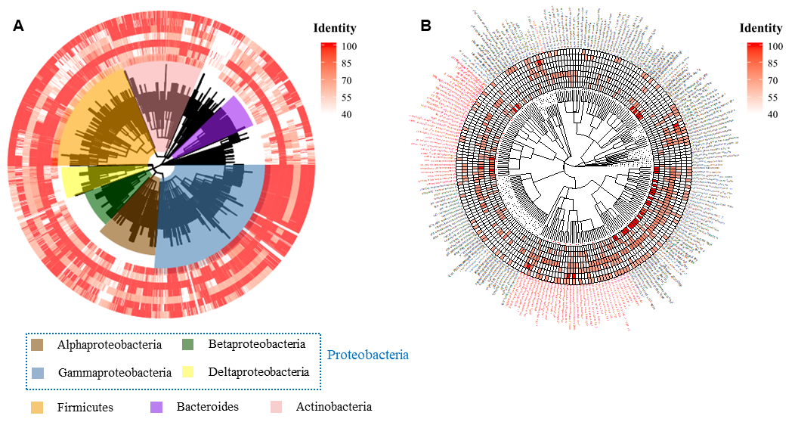

**Figure S1.** Distribution of potential QS genes in bacteria (A) and archaea (B) for which complete genome was available in National Center for Biotechnology Information (NCBI) database. Heatmap for the presence of quorum sensing signal molecules (from inner to outer: AHLs, AI-2, AIP, c-di-GMP, DSF, PQS, Others) (identity≥40%). The red color labels in B represented methanogens.

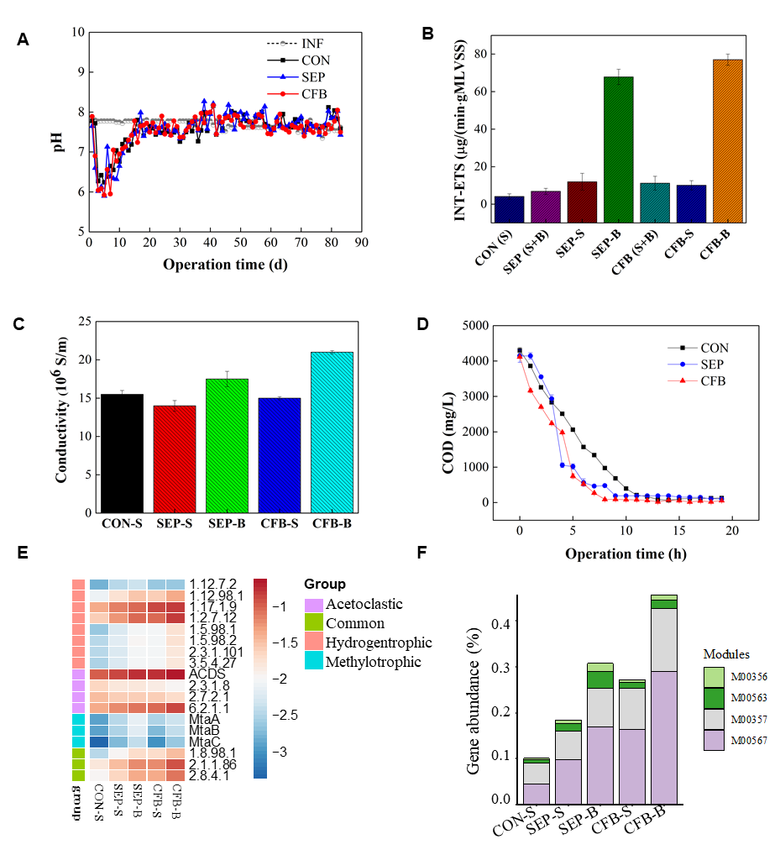

**Figure S2**. Performance of the bioreactors.(**A**) pH value of influent, and effluent of CON, SEP and CFB during the long-term operation; (**B**) Concentration of INT-ETS in sludge (S) and biofilm (M) from CON, SEP and CFB; (**C**) Conductivity of sludge and biofilm from CON, SEP and CFB; (**D**) Dynamics of COD within one reaction cycle operation of CON, SEP and CFB; (**E**) Relative abundance of genes involved in methanogenesis pathways; (**F**) Overall abundance of functional genes in acetoclastic (M00567), hydrogenotrophic (M00357) and methylotrophic (M00356 and M00563) methanogenesis pathways.

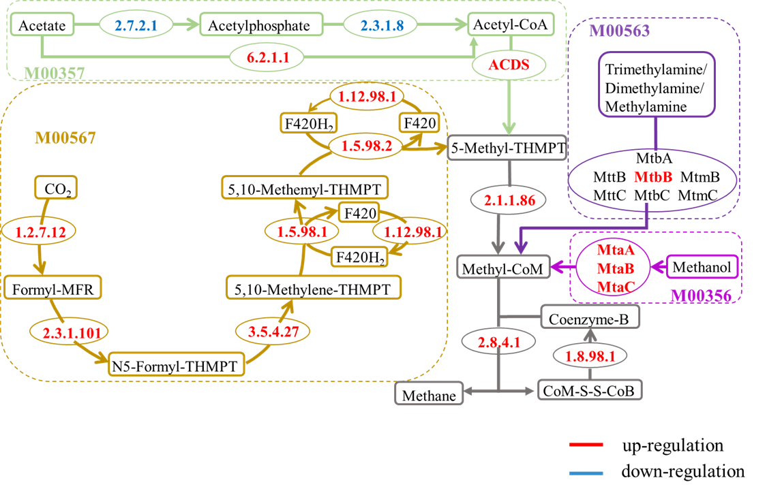

**Figure S3.** Metabolic pathway flow chart and up- and down-regulated genes in CFB bioreactor compared to CON. The four methanogenesis pathways, namely Acetoclastic (module:M00357), Hydrogenotrophic (module:M00567), Methylotrophic (module:M00563 and M00356), and Common were shown in different colors. The enzymes, shown in the ovals, were colored red if up-regulated, and blue if down-regulated.

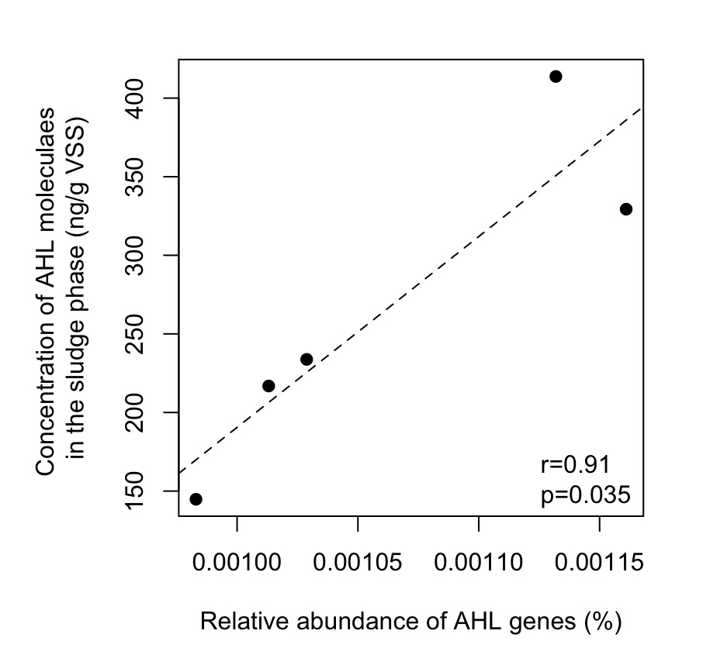

**Figure S4.** Correlation between the relative abundance of AHL genes and the concentration of AHL molecules in the sludge phase in CON-S, SEP-S, SEP-B, CFB-S and CFB-B samples. The dashed line shows the linear regression curve. The Pearson correlation coefficient (r) and p-value, calculated using R, was shown at the right bottom.

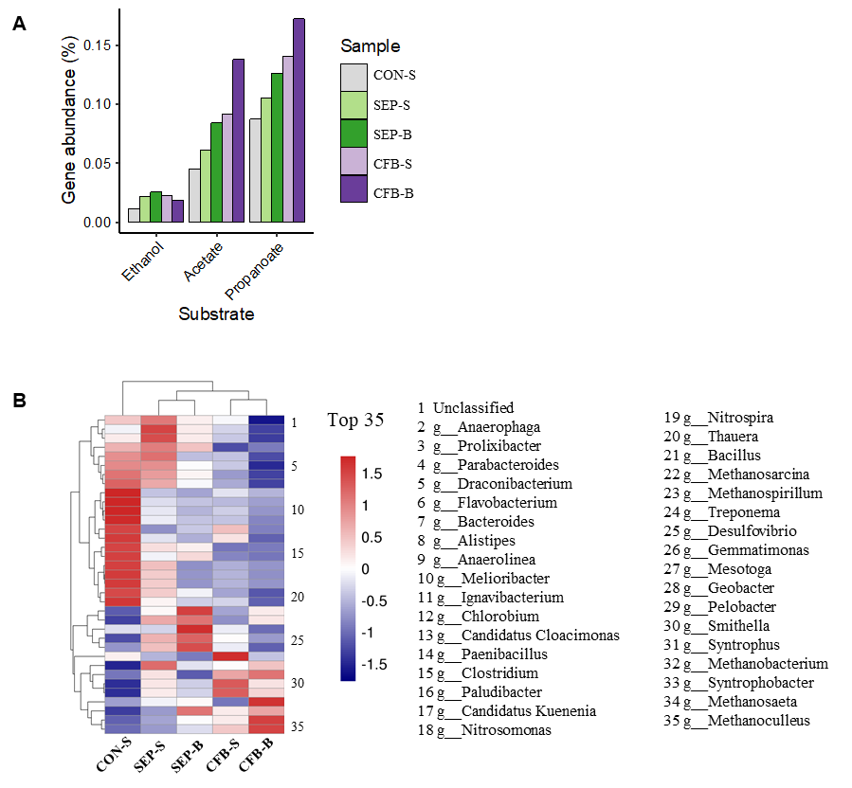

**Figure S5.** (**A**) Abundance of functional genes involved in metabolizing ethanol, acetate and propanoate in CON, SEP and CFB; (**B**) The 35 most abundant genus in sludge and biofilm from CON, SEP and CFB.